**Vorlage Spielfeld. Erreichte Punktzahl nach jeder Spiellektion hier eintragen:**

|  |  |  |  |  |  |  |  |  |  |  |  |  |  |  |  |  |  |  |  |  |  |  |  |  |  |  |  |  |  |  |  |  |
| --- | --- | --- | --- | --- | --- | --- | --- | --- | --- | --- | --- | --- | --- | --- | --- | --- | --- | --- | --- | --- | --- | --- | --- | --- | --- | --- | --- | --- | --- | --- | --- | --- |
|  |  |  |  |  |  |  |  |  |  |  |  |  |  |  |  |  |  |  |  |  |  |  |  |  |  |  |  |  |  |  |  |  |
|  |  |  |  |  |  |  |  |  |  |  |  |  |  |  |  |  |  |  |  |  |  |  |  |  |  |  |  |  |  |  |  |  |
|  |  |  |  |  |  |  |  |  |  |  |  |  |  |  |  |  |  |  |  |  |  |  |  |  |  |  |  |  |  |  |  |  |
|  |  |  |  |  |  |  |  |  |  |  |  |  |  |  |  |  |  |  |  |  |  |  |  |  |  |  |  |  |  |  |  |  |
|  |  |  |  |  |  |  |  |  |  |  |  |  |  |  |  |  |  |  |  |  |  |  |  |  |  |  |  |  |  |  |  |  |
|  |  |  |  |  |  |  |  |  |  |  |  |  |  |  |  |  |  |  |  |  |  |  |  |  |  |  |  |  |  |  |  |  |
|  |  |  |  |  |  |  |  |  |  |  |  |  |  |  |  |  |  |  |  |  |  |  |  |  |  |  |  |  |  |  |  |  |

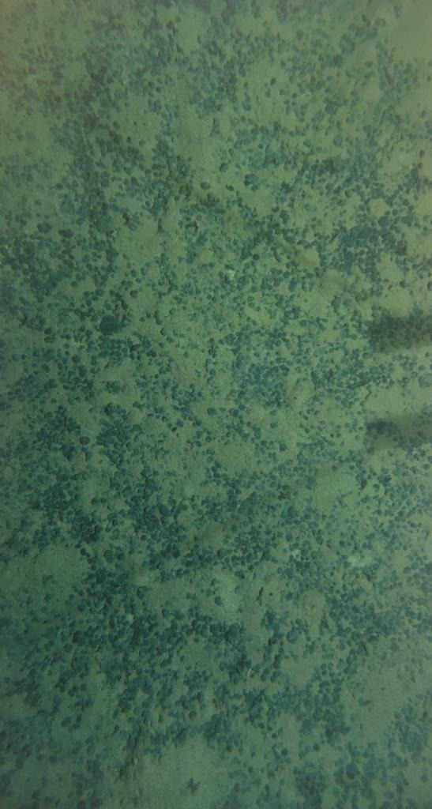**Spielfeldhintergrund (Manganknollenfeld.**